How to Apply NIIT/ITEC COURSES
MEA –ITEC has provided online facilities for filling the application by the applicants.
All new applications are now required to be filled online at the site below (Copy the below URL and paste in your Internet Browser)

https://www.itecgoi.in/courses_list.php?salt3=59e54f6a442017-2018&salt4=41bd96e33810&salt=a42fce247995

Screen short of online filling process for NIIT Courses is as below
- After you open the above mentioned URL, the first screen will show as below
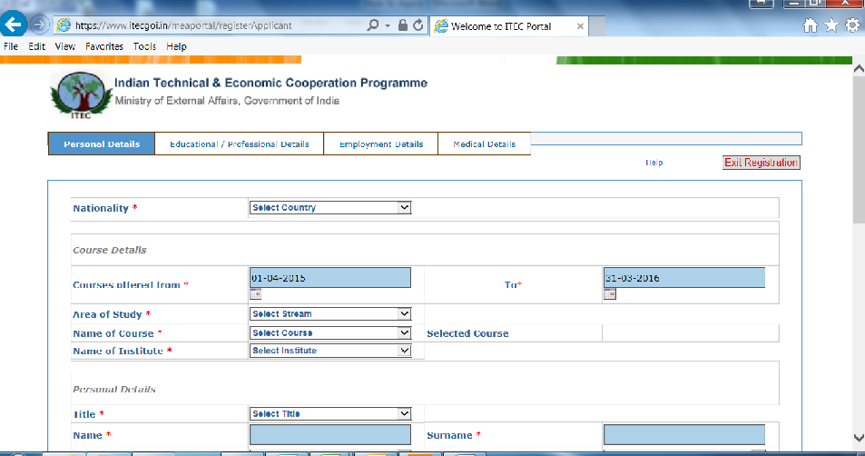
- Fill your Nationality >> Click on Proceed: Fill the course offer from Date as 01-04-2017 to 30-04-2018
- Area of Study field to be selected as >> IT TELECOMMUNICATION AND ENGLISH COURSES
- Now in the NAME OF THE COURSES Already selected by you (Of NIIT courses)
Sl  No | Name of the Course | Duration  (Weeks) | Start  Date | End  Date | Seats  (Max)
1 | CERTIFICATE COURSE IN VOICE AND ACCENT AND MS-OFFICE SKILLS | 8 | 26-Jun-17 | 18-Aug-17 | 30
2 | CERTIFICATE IN ACCENT NEUTRALIZATION, IT AND NETWORKING SKILLS | 8 | 26-Jun-17 | 18-Aug-17 | 30
3 | CERTIFICATE IN ACCENT NEUTRALIZATION, IT AND NETWORKING SKILLS | 8 | 28-Aug-17 | 20-Oct-17 | 30
4 | DIPLOMA IN ADVANCED NETWORKING | 12 | 28-Aug-17 | 17-Nov-17 | 30
5 | CERTIFICATE COURSE IN VOICE & ACCENT AND MSOFFICE SKILLS | 8 | 25-Sep-17 | 17-Nov-17 | 30
6 | DIPLOMA IN ADVANCED NETWORKING | 12 | 30-Oct-17 | 19-Jan-18 | 30
7 | CERTIFICATE IN ACCENT NEUTRALIZATION, IT AND NETWORKING SKILLS | 8 | 27-Nov-17 | 19-Jan-18 | 30
8 | CERTIFICATE COURSE IN VERBAL LINGUISTICS AND WEB DEVELOPMENT | 8 | 29-Jan-18 | 23-Mar-18 | 30
9 | CERTIFICATE COURSE IN VOICE & ACCENT AND MSOFFICE SKILLS | 8 | 29-Jan-18 | 23-Mar-18 | 30
10 | DIPLOMA IN ADVANCED NETWORKING | 12 | 29-Jan-18 | 20-Apr-18 | 30

- After you select course then you can see NIIT LTD in the next field NAME OF THE INSTITUTE
- After this fill all other information and then take a print of the filled application. Submit the Print to INDIAN HIGH COMMISSION of your country.
- Keep checking the status of your application online. Generally these are approved one month before the course starts.

